Contents
Summary 2
Understanding of requirements and scope 2
Modules list with features 2
Non-Functional Requirements 6
Indicative concept design 7
Technical Recommendations 9
Infrastructure recommendations 9
Assumptions 9
Delivery milestones 11
Success criteria 11
Total cost of ownership 12
Annexure 13

Summary
Indexnine understands the critical need for a tailored Real Estate Sales CRM that streamlines lead management, qualification, sales pipeline tracking, and inventory management. Based on the comprehensive requirements outlined in the RFP, we propose a phased implementation approach that will deliver a robust, scalable solution.

Understanding of requirements and scope
We have analyzed your business requirements for the Real Estate Sales CRM system and understand that the primary objectives include:
- Streamlining lead intake from multiple sources
- Implementing a robust lead qualification process
- Creating an efficient sales pipeline management system
- Developing comprehensive inventory, project onboarding, marketing, CRM, billing & accounting, sourcing, corporate, developer, and channel partner management capabilities
- Integrating communication workflows (CTI, WhatsApp, SMS, Email)
Based on the requirements shared on 7th April 2025, the scope of the entire phase is as follows.

Modules list with features

Module | Sub-module | Interface
Application core framework | BE application code setup  FE application code setup  FE Theming setup  FE Common components setup  i18n setup  Authentication layer setup  Exception handling layer  Logger setup
Infrastructure Setup | Repo setup  CICD Pipeline setup  Database setup  Deployment infrastructure setup  Domain setup
Project  Onboarding | Evaluation Criteria | Web
 | Contracts/ Term sheet | Web
 | Approval Lifecycle | Web
 | Pipelines | Web
 | Collateral & Document Collection | Web
 | Inventory Collection | Web
Pre-sales Tech | CTI Integration | Web
 | Bulk Dialer Integration | Web
 | Lead Scoring | Web
 | Lead & Call Routing Engine | Web
 | Goal Tracking | Web & Mobile
Sales Tech | Walk-in Experience | Web & Mobile
 | Quotations | Web & Mobile
 | Approvals on Quotes & Bookings | Web & Mobile
 | Schemes / Offers | Web & Mobile
 | Bookings | Web & Mobile
 | Pipelines | Web & Mobile
 | Incentive Plan | Web & Mobile
 | Goal Tracking | Web & Mobile
 | Virtual walkthroughs, remote selling integration | Web
Mar-Tech | Lead Gen Connectors | Web
 | Marketing ROI | Web & Mobile
 | Bulk Marketing | Web
 | Goal Tracking | Web
 | Collateral Distribution | Web
 | Nurturing Engine | Web
Inventory | Inventory - Units & Pricing | Web & Mobile
 | Region Management | Web
 | Digital Collaterals | Web
 | Availability Management | Web
 | Access Control | Web
CRM Tech | Payments | Web & Mobile
 | Pipelines | Web & Mobile
 | Booking KYC | Web & Mobile
 | Booking Document Generation | Web & Mobile
 | Booking Document Store | Web & Mobile
 | Goal Tracking | Web & Mobile
 | Document Approvals | Web & Mobile
Billing &  Accounting | Developer Invoicing (integrated with Tally) | Web
 | Developer Collections (integrated with Tally) | Web
 | CP Invoicing (integrated with Tally) | Web
 | CP Payments (integrated with Tally) | Web
 | Automated Incentive Payments | Web
 | Billed, Unbilled, Collected -  Receivables | Web
Sourcing Tech | Onboarding | Web & Mobile
 | Clusters/ Regions | Web & Mobile
 | RM Geo Tracking | Web & Mobile
 | RM Visit Tracking | Web & Mobile
 | RM Performance | Web & Mobile
 | CP Performance | Web & Mobile
 | Weekly Predictions | Web & Mobile
Management | Project Insights | Web
 | Cluster/City-wise Insights | Web
 | CP Insights | Web
 | Ratio Analysis | Web
CP Tech | Onboarding | Web & Mobile
 | Leads | Web & Mobile
 | Visits | Web & Mobile
 | Conflict Management | Web & Mobile
 | Bookings | Web & Mobile
 | Invoicing | Web & Mobile
 | Collaterals | Web & Mobile
 | Branded Collaterals | Web & Mobile
 | Broadcasting | Web
 | Incentive Plans | Web
Customer  Tech | EOI | Web
 | Digital KYC | Web
 | Payments - Offline | Web
 | Payments - Online | Web
 | Documentation | Web
Loan/  Fin-Tech | Leads | Web
 | Commission Plan | Web
 | Pipelines Tracker | Web
 | Document Management | Web
 | Invoicing to bank and broker | Web
 | Payouts to brokers | Web
Corporate Tech | Corporate Website | Web
 | Project Micro-sites with CMS | Web
 | Portal - Projects & Inventory | Web
 | Connection to Customer Tech | Web
Developer Tech | Dashboards & Reports | Web & Mobile
 | Approvals | Web & Mobile
Common Core | Workflows | Web
 | Other CRM Integrations (Salesforce, Sell.Do) | Web
 | 10 API Integration | Web
 | 10 Webhooks Integration | Web
 | Audits logs | Web
 | Reporting & Dashboards (10 Each) | Web & Mobile
 | Custom Attributes/ Fields | Web & Mobile
 | Role-Based Access Control | Web
 | Export import on Core Domain Objects - Leads, Site Visits, Inventory, Bookings  Export - CSV format | Web
 | User Management | Web

Non-Functional Requirements
- Responsive Web UI, Tablet-friendly
- Role-based access control across services
- Cloud-agnostic (prefer AWS for initial deployment)
- Observability (logging, metrics)
- Scalability, Availability, Concurrency, Reliability
- Performance Testing
- Security testing
- Web and Mobile application Usability & Accessibility
- REST Standard - Level 2
- Sonarqube - Code quality, vulnerability, code smells.

Note: NFR like Performance testing, Scalability, Availability, Concurrency, Reliability will be discussed and agreed mutually in the Discovery and Design Phase

Hypercare will be provided for 60 days post go live (R4) or 75 days from UAT sign off whichever is earlier. Hypercare period is to fix any bugs and to provide support to end users to help them to adopt the system. Changes if any in this period will be treated as change requests.

Out of scope
- All items that are not listed in the above scope.

Indicative concept design
Please note: This is an indicative concept only and final design may vary from the concept.

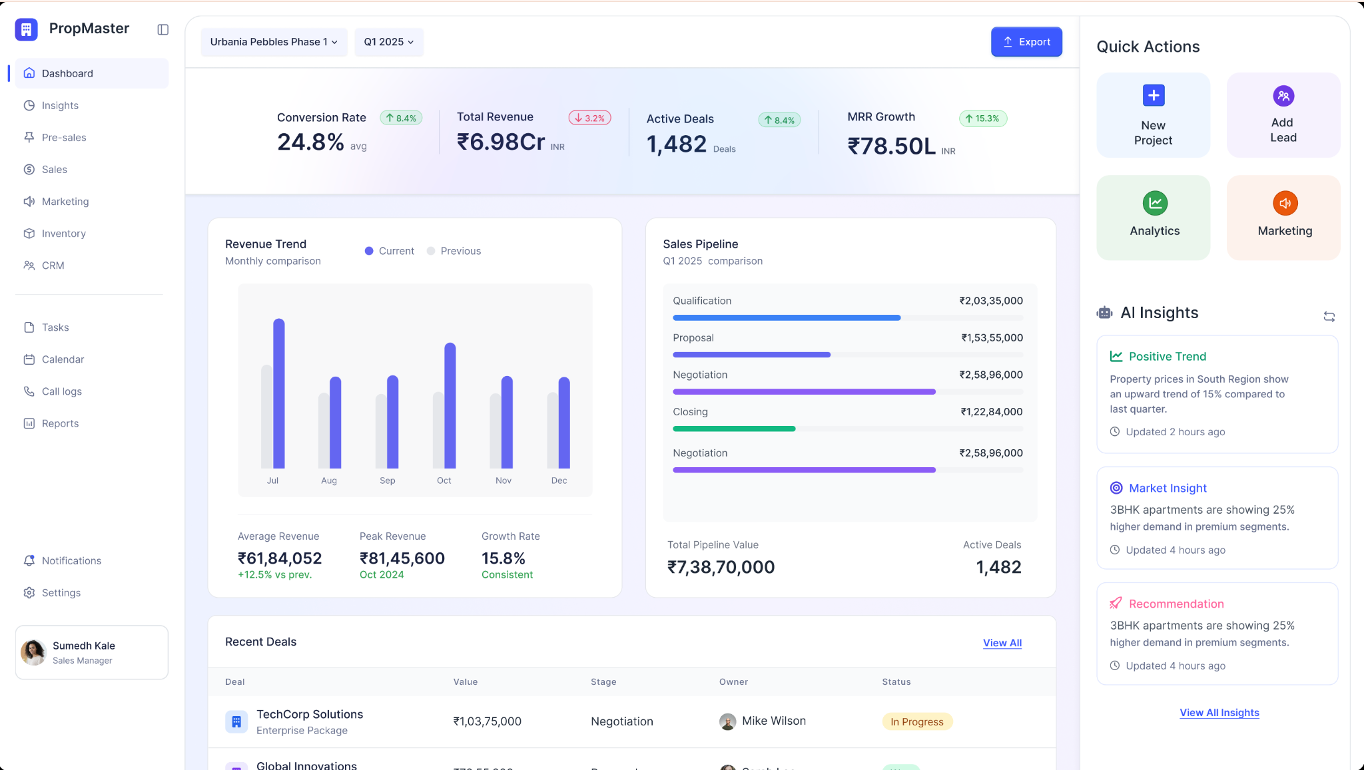

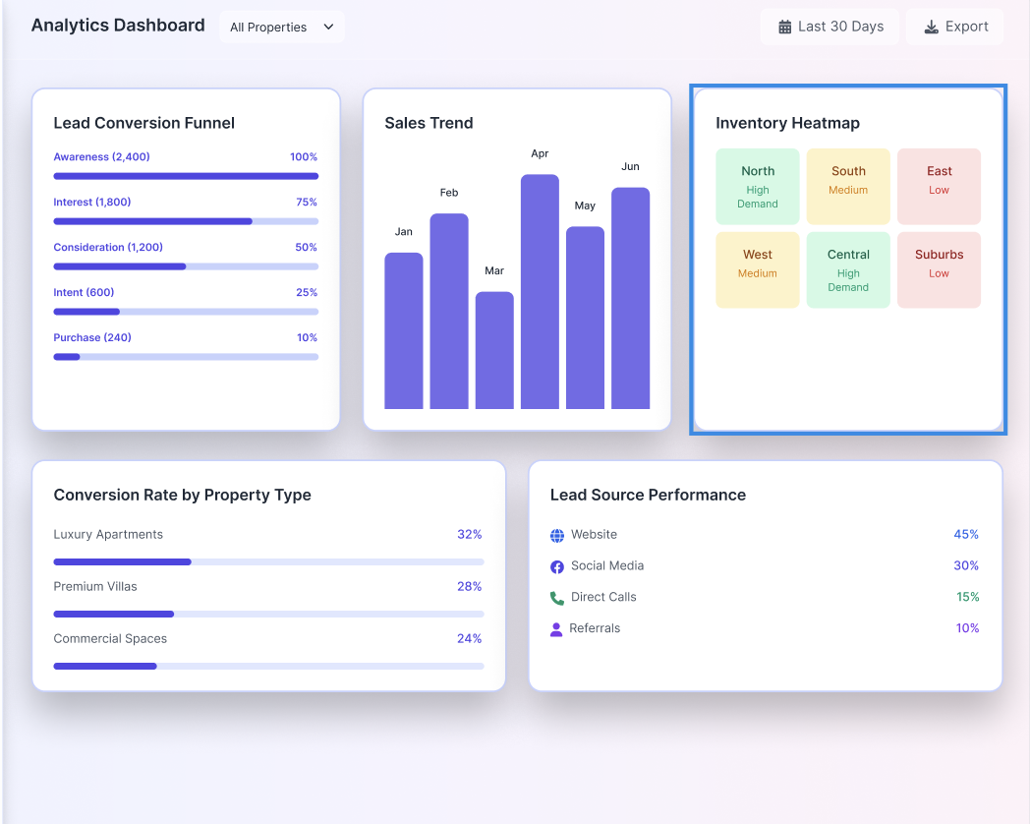

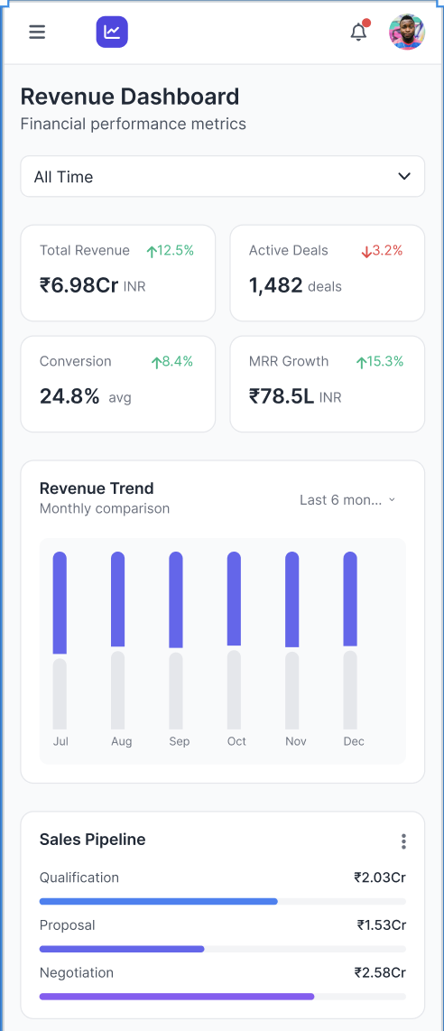

Technical Recommendations
The following technology stack is considered for the estimation.

- Frontend: ReactJS
- Backend: NestJS framework, Node.js
- Mobile: Flutter
- Database: MongoDB/Postgres
- Infrastructure: AWS (CloudFront, EC2/EKS, VPC, Route53), Terraform for IaC
- DevOps: CI/CD pipelines, containerized deployments (Docker/Kubernetes)
- Observability setup

Infrastructure recommendations
The following infrastructure is recommended for development and production.

- Application Hosting:
  - Website and backend services hosted on AWS S3, EKS, and EC2
- Data Management:
  - Persistent storage and caching via RDS, ElastiCache, and S3
- Traffic Routing & Security:
  - Application served through Route 53, API Gateway, Network Load Balancer (NLB), and AWS Security Groups
- Monitoring & Observability:
  - Leveraging Amazon CloudWatch for real-time insights and performance tracking

Indicative costs:
Year 1: ₹10 Lakhs + GST
Subsequent Years: ₹30 Lakhs + GST annually

Please note: Note: Infrastructure will be provisioned, owned, and paid for separately by Justo. These are estimated costs based on expected usage.

Assumptions
Development & Deployment methodology
The platform will be used by a single tenant only. Hence multi-tenancy is not considered in any of the layers like - Infrastructure, WEB Application BE Application, Mobile Application, Database, White labeling and any other multi-tenancy feature.

Authentication setup
The authentication feature will not have any external services integrated like social login using gmail or facebook, it will use JWT header based authentication. The OTP will be sent via SMS and Email using the communication channels that the platform will have integrated.
Hence, SSO, Social Login, oAuth or any other external service integration is out of scope.

Label / Locale Management (I18n)
The data will be stored and displayed only in English. The static content on the web pages can be in multilingual format. Indexnine will produce a mapping file of English-Other language for verification by Justo.

Users management
The platform will manage the users internally and there will be no external identity providers or services integrated for any user management operations.

API support for external lead creation
The authorization mechanism for the external services will be JWT based and there will be no client management on GUI. We will need more details on external services integrations.

Import & Export
Only the CSV file type is considered.

Existing data migration
Any existing data migrating into the new platform is out of scope in this phase.

Other Key Assumptions
- Client will provide timely access to key stakeholders for interviews and feedback
- Client will provide necessary access to third-party systems for integration
- Client will assign a dedicated project coordinator for day-to-day communication
- Client will allocate resources for user acceptance testing
- The scope of requirements will remain stable throughout the development phases
- Any changes to requirements will be managed through a formal change control process
- Client will provide the necessary brand guidelines and content for the user interface
- Client will be responsible for any third-party subscription costs (Mailgun, Pinnacle, etc.)
- Client will provide necessary infrastructure and access for deployment

Delivery milestones

Phases | May – Sep’25 | Oct’25 – Jan’26 | Feb - May’26 | Jun - Sep’26 | Oct - Nov’26
UX + VD + Discovery | Phase 1
Architecture Design + Application scaffolding
Lead, Goal, Call, CP, Dashboard, Report Management
Access & Security
UAT & Go Live | R1
Lead & Sales Management
Marketing & Engagement
Onboarding & Access Management
Regional & Organizational Structure
Access & Security
UAT & Go Live |  | R2
Inventory & Pricing
Finance & Payments
Insights & Reporting
Automation & Workflows
Access & Security
UAT & Go Live |  |  | R3
Sales & Performance Tracking
Marketing & ROI Analysis
Finance & Payments
Financial Insights & Analysis
CRM & Third-Party Integrations
Compliance & Approval Management
Collateral & Data Collection
Customer & Sales Experience
Digital Presence & Customer Access
UAT & Go Live |  |  |  | R4
Hypercare

Updated delivery timetable
Phases | Jun – Nov’25 | Dec’25 – Feb’26 | Mar - Apr’26 | May - Sep’26 | Oct – Dec’26
UX + VD + Discovery | Phase 1
Architecture Design + Application scaffolding
Lead, Goal, Call, CP, Dashboard, Report Management
Access & Security
UAT & Go Live | R1
Digital EOI for pre-launch
CP & employee dashboard
Developer Dashboard
UAT & Go Live |  | R2
Lead & Sales Management
Marketing & Engagement
Onboarding & Access Management
Regional & Organizational Structure
Access & Security
UAT & Go Live |  |  | R3
Inventory & Pricing
Finance & Payments
Insights & Reporting
Automation & Workflows
Access & Security
UAT & Go Live |  |  |  | R4
Other services |  |  |  |  | R5

Success criteria
- Discovery and design phase
Indexnine will commence the project with a comprehensive Discovery and Design phase to establish a solid foundation for the Real Estate Sales CRM development. This structured approach ensures alignment between business requirements and the technical solution. Our team will conduct the following discovery activities
- Stakeholder interviews
- Persona development
- Journey mapping
Following the discovery phase, Indexnine will execute a two-iteration design process:
- First Iteration Deliverables:
  - Initial wireframes for core system workflows
  - Preliminary clickable prototype demonstrating key user journeys
  - Justo will review and provide consolidated feedback within 5 business days
- Second Iteration Deliverables:
  - Refined wireframes incorporating stakeholder feedback
  - Enhanced clickable prototype with improved user experience elements
  - Final documentation of design decisions and rationale
  - Justo commits to reviewing and providing final sign-off within 5 business days of receiving the completed wireframes and clickable prototype
Any iterations beyond this will be treated as a change request.
- Build and Go Live
Indexnine will deliver the product based on the signed off requirements, wireframes from design phase. Justo will conduct UAT before each release. The acceptance will be based on following

- The signed off functionality post discovery and design phase will be the basis for UAT and final sign off
- The system successfully integrates with all specified third-party services
- The web application is responsive and functions correctly on desktop, tablet, and mobile devices
- All specified user roles and permissions function as required
- All documentation has been delivered and approved
- User training has been completed
- No critical or high-priority bugs remain unresolved
Any changes to requirements will be managed through a formal change control process

Total cost of ownership
The Total cost of ownership for the development, delivery and adoption will be INR 7.7 crores + GST (INR seven crore and seventy lacs + GST).
Note: Some of the costs provided herein are estimates based on anticipated usage. All maintenance, infrastructure, and other related costs shall be borne separately by Justo. The necessary infrastructure shall be provisioned, owned, and funded independently by Justo.

Payment Schedule:

We propose the following payment schedule:
- 10% upon contract signature
- 25% upon R1 go live
- 20% upon R2 go live
- 20% upon R3 go live
- 20% upon R4 go live
- 5% upon completion of 60 days of Hypercare

Validity:
This commercial offer is valid till 31st October, 2025

Annexure
The calculations are provided as indicative total cost of ownership of Project Manthan.
Justo Total cost of ownership for Project Manthan over 24-month period
Indexnine cost sheet | Cost w/o GST | DETAILS
Contract signature | ₹ 63,00,000 | First Phase - Contract Signature
R1 (corresponding to P0 items) | ₹ 1,57,50,000 | Release 1 - Architecture design, application scaffolding, Lead management, Goal tracking, Access , security
R2 (corresponding to P1 items) | ₹ 1,26,00,000 | Release 2 - Lead & Sales Management,Marketing & Engagement, Onboarding & Access Management, Regional & Organizational Structure,Access & Security
R3 (corresponding to P1 items) | ₹ 1,26,00,000 | Release 3 - Inventory & Pricing,Finance & Payments,Insights & Reporting, Automation & Workflows, Access & Security
R4 (corresponding to P4 items) | ₹ 1,26,00,000 | Release 4 - Sales & Performance Tracking, Marketing & ROI Analysis, Finance & Payments, Financial Insights & Analysis, CRM & Third-Party Integrations, Compliance & Approval Management, Collateral & Data Collection, Customer & Sales Experience, Digital Presence & Customer Access
Final payment | ₹ 31,50,000 | Final Phase - Hypercare
Total development Cost | ₹ 6,30,00,000
Maintenance & other costs **
Maintenance Cost for 2 years post-development | ₹ 60,00,000
Cost of external functional consultant | ₹ 40,00,000
Total delivery cost | ₹ 1,00,00,000
Infra Cost - Expected annual spend for Production (AWS/Azure hosting with DevOps)
2025-26 | ₹ 10,00,000
2026-27 | ₹ 30,00,000
Total Operation Cost | ₹ 40,00,000
TOTAL COST OF OWNERSHIP | ₹ 7,70,00,000

